| **CSIC30100: Brain Computer Interface** | **(Due: 06/02/2023)** |
| --- | --- |
| Final Car Competition | |
| Instructor: Chun-Shu Wei  TA: | Student Id |

## **Introduction**

For the final car competition, you will be extending your work from the midterm mind-controlled car demo by controlling the car to turn right and left using hybrid-BCI approach. Hybrid-BCI means you can use information or features other than EEG (e.g., artifacts, additional measurements on EEG devices) as the control signal. The competition objective is to control your car and finish a track set up by the TAs.

## **Schedule**

* EEG device test and algorithm development (6 weeks)
  + 12:00~13:00 every Friday (after class) from 4/21 to 5/26
* Final competition (1 week)
  + 6/2 , adjustments on site is allowed

## **Rules**

* Controls allowed for Hybrid BCI *
  + EEG**
  + Physiological artifacts ( e.g., EOG, EMG, ECG )
  + Gyroscope of EEG device ( Acceleration and angular acceleration on X, Y, Z-axis )
* Each group will have 3 trial opportunities in the competition, each trial less or equal to 10 minutes.

* Keyboard control, physical displacement or any other controls not listed above are all forbidden

**Since this is BCI course, EEG is required

## **Grading Policy**

* Basic functionality (0%)
  + Show the sources / algorithms / logics your group utilized for the controls
    - Move forward
    - Turn left
    - Turn right

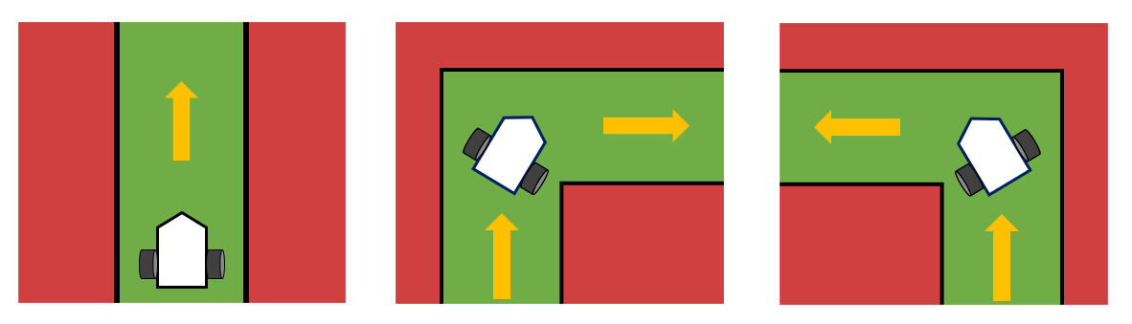

* Tiers (100%)
  + Basic tier scoring + time cost ranking
  + **A**: 95 points + in tier ranking by 3 points interval
  + **B**: 75 points + in tier ranking by 3 points interval
  + **C**: 60 points + in tier ranking by 2 points interval
  + **D**: 50 points + in tier ranking by 2 points interval

|  | EEG BCI | Hybrid BCI |
| --- | --- | --- |
| Checkpoint 1 | C | D |
| Checkpoint 2 | B | C |
| Checkpoint 3 | A | B |

(For example, if 3 teams reach tier B, the grades will be 75+3*2=81, 75+3=78, 75 respectively base on their finish time)